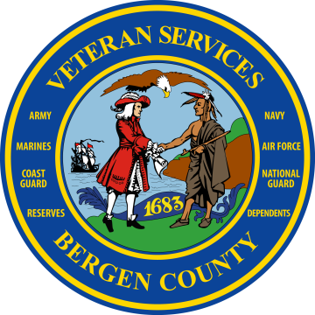
Job Description

Position Description for VA work study: The VA Work Study will be a highly utilized asset to the Bergen County Division of Veteran Services..

• Providing general information regarding Veterans education benefits and other veteran benefits for Northern NJ veterans and dependants.

• Assisting veterans with general inquires about veteran benefits via phone, email, and in person.

• Assist with scheduling appointments.

• Maintain and organize veteran-related files.

• Assist with intake processing of veteran clients.

• Assist in maintaining positive relationship with key offices in order to facilitated services to
veterans related benefits.

• Assist in gathering veteran documentation.

• Assist with development and distribution of accurate and current Veterans Affairs publications.

• Assist with outreach and veterans events.

Point of Contact
Ariel Jacob Luna
Veteran Services Office
1 Bergen County Plaza, 2nd Floor
Hackensack, NJ 07601

Tel- 201-336-6326
Fax- 201-336-6327
Email- aluna@co.bergen.nj.us

